FOR IMMEDIATE RELEASE
CONTACTS:
DOMINIQUE ELLIS
dellis@theehrhardtgroup.com
(504) 250-0030

MALCOLM EHRHARDT
Malcolm@theehrhardtgroup.com
(504) 495-9850

DARLENE CUSANZA
Darlene@crimestoppersgno.org
(504) 837-8477

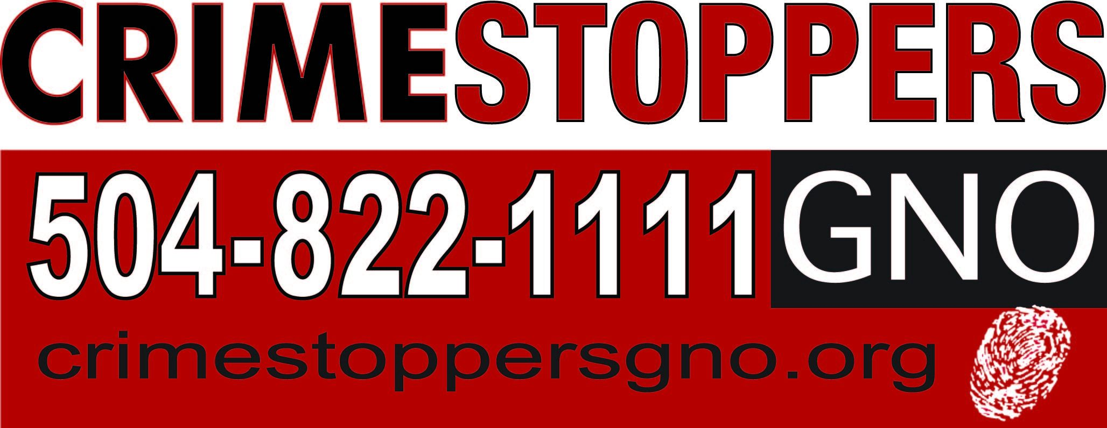

CRIMESTOPPERS GREATER NEW ORLEANS CALLS ON COMMUNITY
TO STAND UNITED AGAINST VIOLENCE
Organization Leaders Partner With Local Clergy, Law Enforcement
and Community Groups In Moment Of Prayer and Call To Action

In response to recent multiple shootings and increasing homicides in the city, Crimestoppers Greater New Orleans (Crimestoppers GNO) and Project Good Samaritan Chairs, Archbishop Gregory Aymond and Pastor Antoine Barriere, are requesting the community come together on Friday, June 23 at 11:15 a.m. at the Saint Louis Cathedral. At the event, Crimestoppers GNO will announce an increased reward for tips in shootings and homicides.
The reward increase will last over the summer months and be implemented throughout the nine parishes the non-profit organization serves. Crimestoppers GNO serves as an invaluable resource to the local community, providing concerned citizens with a safe and anonymous way to report and reduce crime in their neighborhoods.
In addition, Crimestoppers GNO is calling for a day of prayer and healing. Members of the clergy, law enforcement, victims’ families and other local service providers will unite in prayer at the event to begin the process of healing from the sting of violence recent events have wrought.
“It is time to begin the healing process and unite against violence in our city,” says Cusanza. “There are a number of ways community members can get involved and I invite each and every concerned citizen to join us in this effort.”

Stand United in Prayer
Following the call to prayer on Friday June 23, Crimestoppers Greater New Orleans will be announcing a monthly day of prayer and healing. Once a month, church bells will ring throughout the city and call for citizens to stop for a moment of reflection. Crimestoppers GNO is also calling on citizens to provide prayer requests at participating churches for congregations to hold up in prayer. Prayer request submissions can be made online at goo.gl/4zwrKp.
Cusanza will also announce materials available to assist Crimestoppers as they celebrate the 2017 National Night Out Against Crime.
WHO: Darlene Cusanza, President and CEO of Crimestoppers GNO
Archbishop Gregory Aymond, Archdiocese of New Orleans
Pastor Antoine Barriere, Household of Faith
Michael S. Harrison, Superintendent of the New Orleans Police Department
Joseph Lopinto, Jefferson Parish Sheriff, Chief of Operations and Chief Criminal Deputy
Jim Letten
Jay Batt, Chairman of the Crimestoppers Board of Trustees
Members of Crimestoppers Board of Directors
Members of the Project Good Samaritan
Members of parish, state and federal law enforcement
Family members of recent shooting victims
Neighborhood and Civic Association members

WHAT: Crimestoppers GNO press conference, reward announcement and call to prayer

WHERE: Saint Louis Cathedral, 615 Pere Antoine Alley, New Orleans, LA 70116

WHEN: Friday, June 23, 2017. Press conference will start promptly at 11:15am CST

PHOTO/VIDEO OPPORTUNITY: Members of the media are invited to the event to hear comments from President and CEO Darlene Cusanza, members of the clergy, law enforcement officials, community groups and victim’s families.

About Crimestoppers Greater New Orleans: Crimestoppers Greater New Orleans, is a 501 (c)3 non-profit organization that works in cooperation with local law enforcement, media, and the general public to solve and prevent crimes in the parishes of Orleans, Jefferson, St. Bernard, St. Charles, St. James, St. John the Baptist, St. Tammany, Plaquemines and Washington. To report a crime tip please call (504) 822-1111. To find out more visit www.crimestoppersgno.org

###

