Bringing faith leaders together to foster peace
Published on Tuesday, 17 May 2016 10:06 | Written by Archbishop Gregory M. Aymond | |
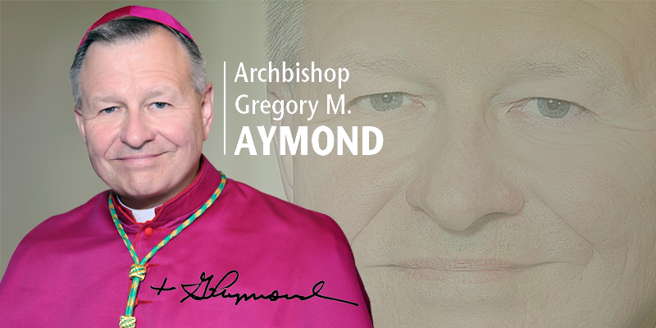
You’re hosting a luncheon on May 26 for faith leaders around the metropolitan New Orleans area to discuss violence and murder in our community. Can you talk about that?
Yes. We’ve invited numerous faith leaders from around the New Orleans area to come together to discuss the violence and frequent murders that happen in the New Orleans area. Darlene Cusanza, the president of Crimestoppers of Greater New Orleans, met with me and asked if I would be willing to partner with her in calling a meeting of faith leaders in order to discuss this. We’ll be talking about what we can do to address violence in general. But more specifically, we want to make our congregations aware that using Crimestoppers truly helps to bring about a more peaceful city. I like very much what Crimestoppers says: “Silence is violence.” If we have information about a crime and we withhold that information from the police who are trying to arrest the person responsible for the crime, we contribute to the violence. We’ll also be hearing from Bishop James Williams, who oversees a Protestant church in Detroit, about his efforts bringing church groups together to bolster the effectiveness of Crimestoppers.
Have you heard that people are afraid to call Crimestoppers?
Yes. People are afraid to call and give tips because they are afraid that if their names become known, they will be targets for revenge. Crimestoppers is very clear that a person calling in with information never has to give his or her name. The person can call anonymously and just say, “This is what I know. Use the information if you can.” We as a community have to work together. Crimestoppers serves not only the city of New Orleans but also every civil parish within the Archdiocese of New Orleans.
There have been other faith-based initiatives over the past 20 years to combat violence, and it’s been a little bit of a roller coaster in terms of sustaining the effort of church groups. Will you be talking about how to keep things effective for the long haul?
Yes. We’ve gotten together as faith leaders to talk about violence in our community. We’ve also met with Mayor Landrieu and Superintendent Harrison. We’ve tried various approaches, which have worked to some extent, but we all know the violence has continued. We have to continue to meet to see what more we can do. I always say, we’ve done a lot, but there’s more to do. As long as the violence continues, we as faith leaders should be concerned. We want to help the police department. We want to help Crimestoppers. We want to be a source of peace, and that starts with providing information that can prevent violence.
What steps has the archdiocese taken to combat violence?
We’re doing a lot through our Isaiah 43 program to take young people who are in challenging situations and mentoring them. I’ve been deeply impressed by the young people who have gone through the program. I’ve met them. Several of them have formed a leadership group and are working with their peers. They’re also spreading their message to people in positions of authority. We have a program to provide parents with parenting skills. We also have our Family Prayer. I believe very much in the power of prayer. Our prayers are always answered in God’s time. It’s important to me that we continue to pray the Family Prayer at every Mass in every parish throughout the archdiocese. We won the Battle of New Orleans 201 years ago, and we are grateful. But today we face a different kind of battle – against violence, murder and racism. We as faith-filled people must pray and act in such a way to bring about peace. Sometimes people ask, “Well, what can I do?” We can cooperate with Crimestoppers, but we also can try to bring peace within our neighborhoods and families. We also need to work within our own lives. We can work toward peace, not revenge. That has a rippling effect. If we, by our example, do that, we can help others do it, and then we will have a greater movement toward peace. We can safely say that every area of our archdiocese has been directly affected by violence, murder and racism. We cannot give up. We’re not hopeless people. We never despair. Therefore, we must pray and continue to act with vigor and enthusiasm.
- See more at: http://clarionherald.info/clarion/index.php/archbishop-aymond/5583-bringing-faith-leaders-together-to-foster-peace#sthash.B3E1hDtp.dpuf

